#### 

Athlone Institute of Technology

Athlone

REPORT

Hotel Booking Manager

Software Design 4.1

Abhik Rai

A00258752

**ABSTRACT**

A Java application which provides the feature of managing the hotel bookings. The main features of this application are:

1. **Add Hotel Booking:** Add Booking Details and saving them in a linked list.
2. **Show Bookings:** Displaying the total number of bookings with the details.
3. **Delete Bookings:** Either deleting the first booking or deleting all the bookings.
4. **Search Booking:**  Searching for the booking details of a specific person name.

This project is implemented using functionalities like Window Builder, Inheritance, Aggregation and Linked Lists.

**INTRODUCTION**

Hotel Booking Manager helps us to manage the booking details of customers.

It is an application which would be helpful for any user who wants to manage the hotel bookings in his/her hotel.

**SCOPE OF WORK**

**Objective:**

The main objective of the project:

* To store booking details.
* To display booking details.
* To search for a booking
* To delete a booking

**Limitations:**

* Basic U.I
* Limited details can be entered

**Environment:**

Hardware :

Processor : Intel Core i3

Random Access Memory : (Minimum) 512 MB

Hard Disk : 1 GB

Software :

Developing Application : Eclipse Oxygen

Front-End : Java

Operating System : Windows10

**Functionalities Used:**

* Window Builder
* Aggregation
* Inheritance
* Linked Lists

**IMPLEMENTATION & FUNCTIONALITIES**

* **Class Person**

To get the persons name and contact number.

**Implementation :**

Created a function readName() which returns the person name and contact number.

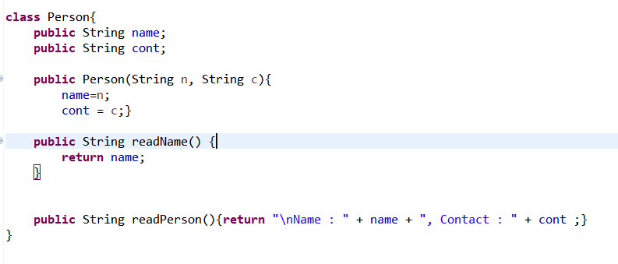

* **Class Booking**

To get the all the booking details of the person.

**Implementation :**

Using Inheritance to extend the class Person.

**resetTime()** will reset the time to null.

**getDetails()** will return all the persons booking details

**print()** will print the details on the console

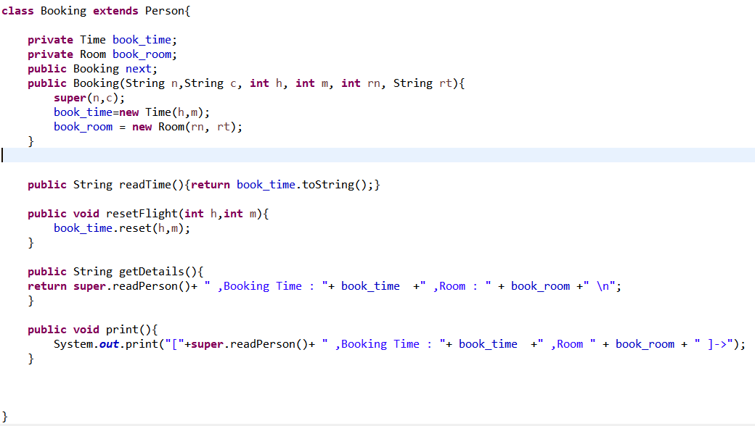

* **Class Room**

To get the room number and room type.

**Implementation :**

Returns the room type and room number.

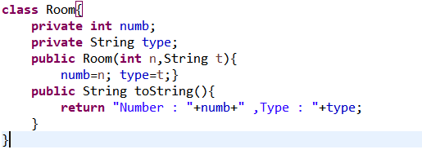

* **Class Time**

To get the booking time.

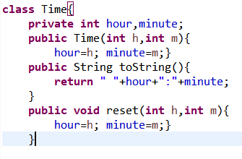

* **Class LinkedList** (collection) of the Objects.

**Implementation**

Creating objects and functions to save all the booking details into a linked list

**Insert()** inserting all the details

**Count()** it counts the number of bookings

**deleteFirst()** deletes the first booking from the top

**deleteAll()** deletes all the booking

**printList()** prints the details on the console

**getList()** return the list of booking with details

**Search()** searches for a booking from the name of the person

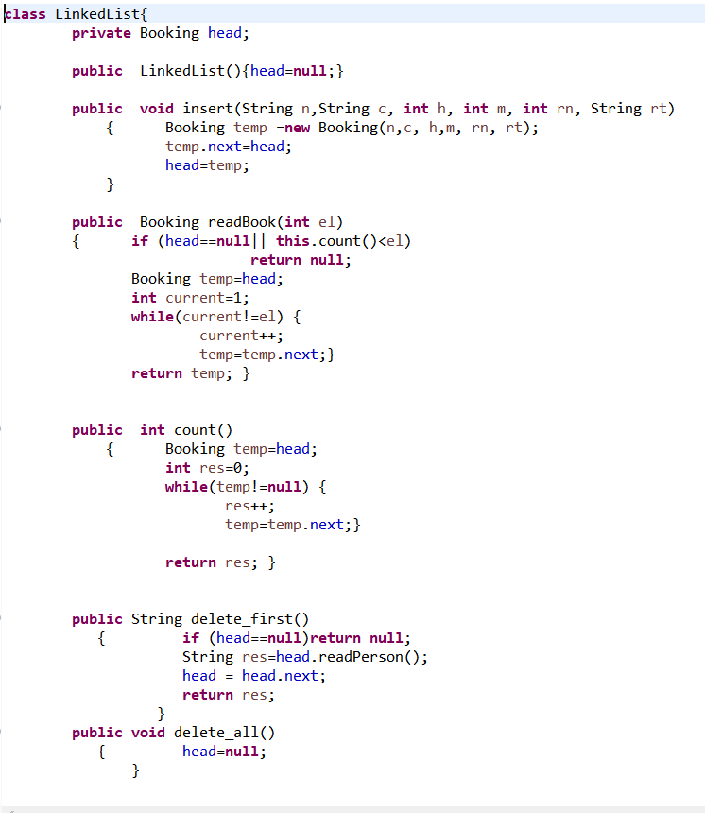

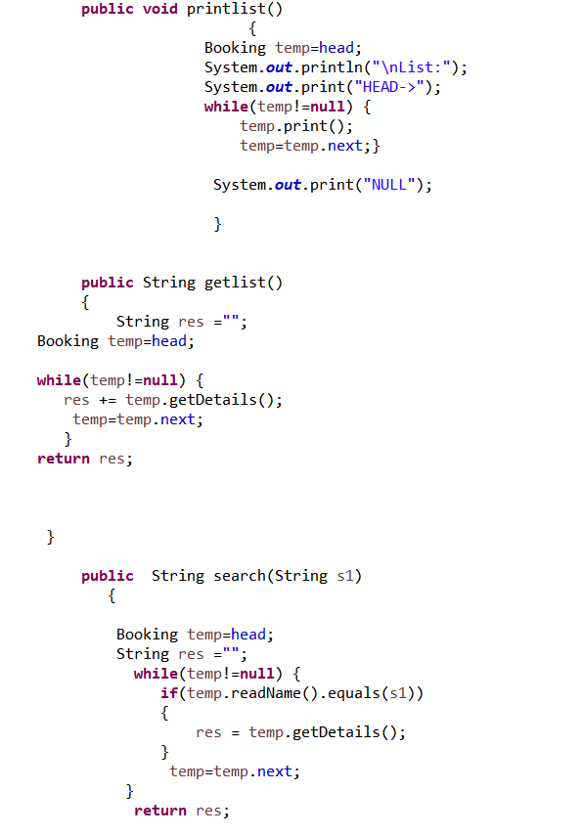

**SCREENSHOTS**

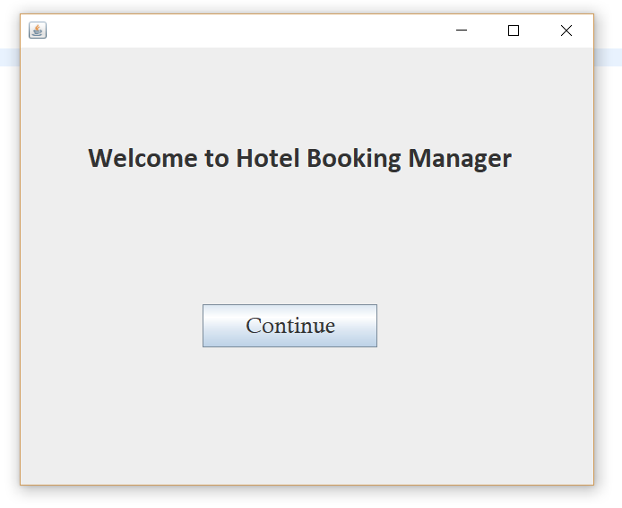

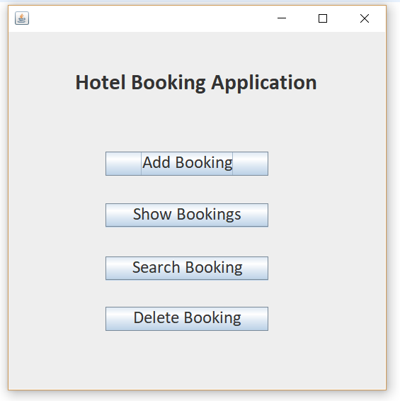

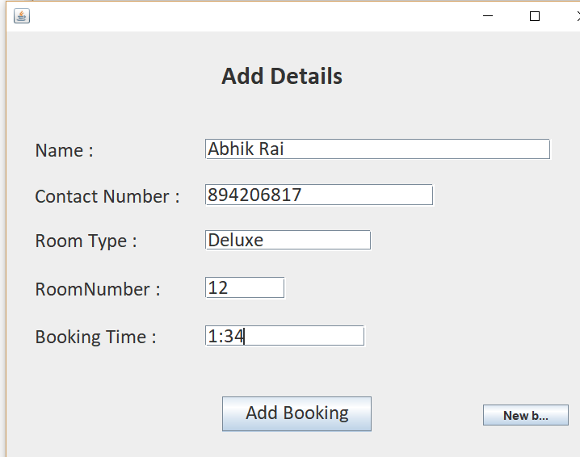

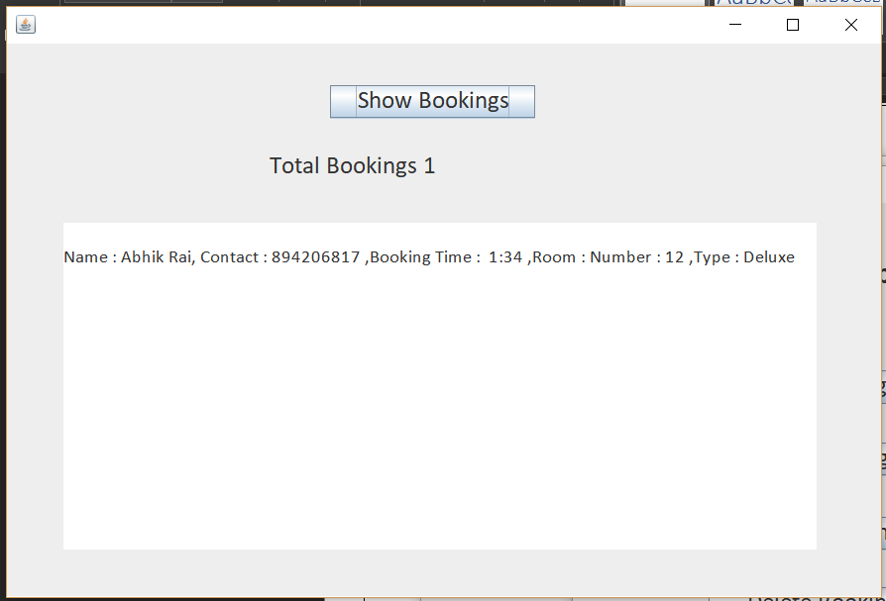

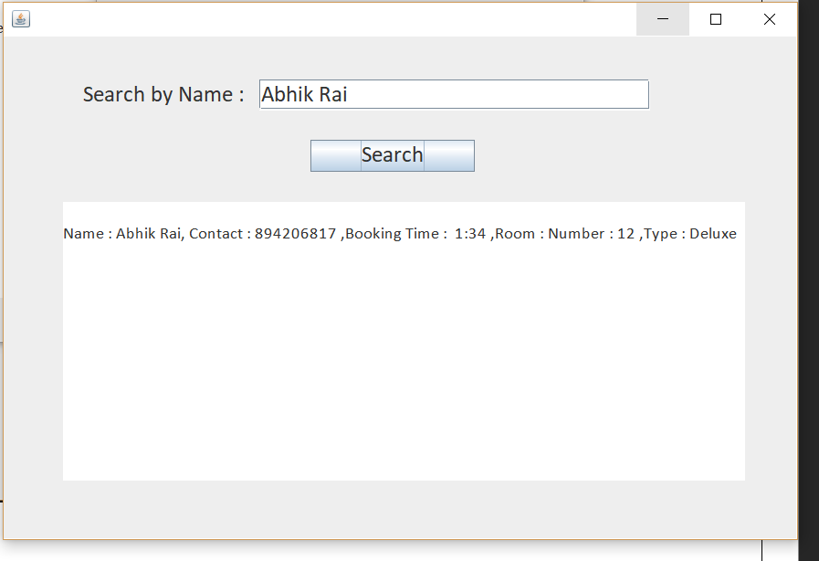

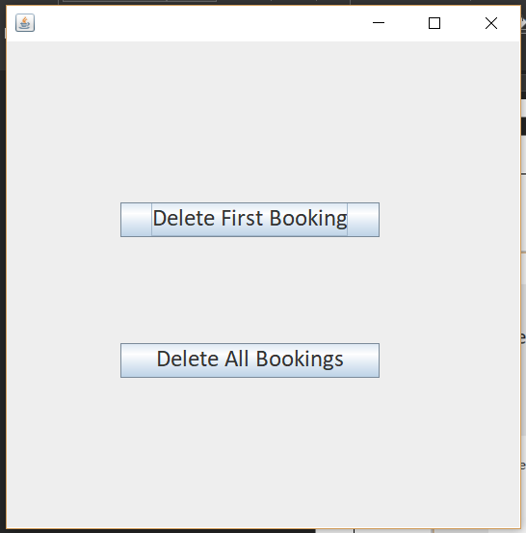

**PROBLEMS**

Implementing this application was not easy.

The main problem I faced was to know how to fetch the data from the Linked List to different Window Frames.

The one problem I still have is that there is no back button in the application so when we click on the button and go to new window the old window is still open. And when we close one window the whole application closes.

**CONCLUSION & LEARNINGS**

In this project I got to know about the working of Linked Lists and how it is implemented to store all the objects.

Inheritance makes the implementation very easy instead of writing the same code again and again

The aggregate class contains a reference to another class and is said to have ownership of that class. Each class referenced is considered to be part-of the aggregate class.